6. NS.6c Coordinate Plane and Number Lines School Net Practice A

11. | Which two points on the number line are 5 units apart?  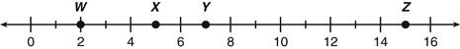
 | A. W and Y
 | B. W and X
 | C. X and Z
 | D. Y and Z
12. | Which ordered pair lies within both circles on the coordinate plane below?
 | A. (0, 3)
 | 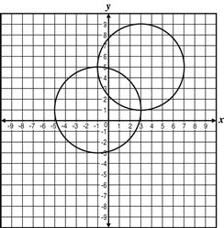
 | B. (2, −2)
 | C. (3, 1)
 | D. (4, 0)

13. |  | Which of the following points lies on the x-axis?
 |  | A. (–4, 0)
 |  | B. (1, –3)
 |  | C. (0, 5)
 |  | D. (–2, 6)
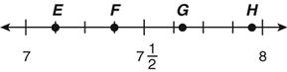
14. | Which point is best represented by
 | A. E
 | B. F
 | C. G
 | D. H
15. | Which point is closest toon the number line below?  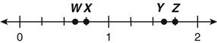
 | A. W
 | B. X
 | C. Y
 | D. Z

16. | Which letter best representson the number line below?  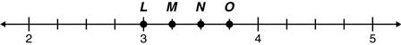
 | A. L
 | B. M
 | C. N
 | D. O

17. | Which point representson the number line below?
 | A. W
 | B. X
 | C. Y
 | D. Z

18. | Which point is located at (–6, 3)?  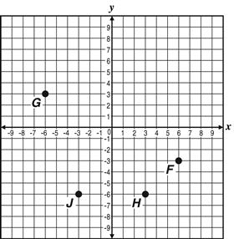
 | A. F
 | B. G
 | C. H
 | D. J
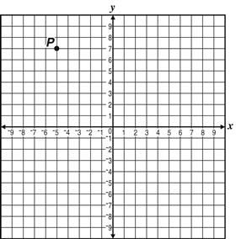
19. | Which of the following ordered pairs describes the location of Point P?
 | A. (–7, –5)
 | B. (–7, 5)
 | C. (–5, –7)
 | D. (–5, 7)

20. | Which number is closest to Point Z on the number line below?  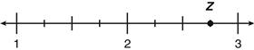
 | A.
 | B.
 | C.
 | D.

