6. NS.6c Coordinate Plane and Number Lines School Net Practice B Homework
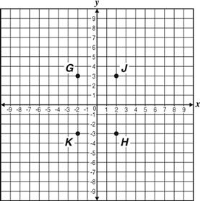
21. | Which point has the coordinates (–2, 3)?
 | A. G
 | B. H
 | C. J
 | D. K
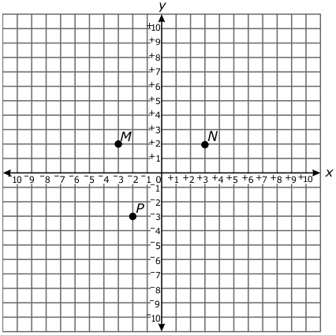
22. | Which point on the graph below is located at (–2, –3)?
 | A. M
 | B. N
 | C. P

23. | On the number line below, which point represents
 | A. F
 | B. G
 | C. H
 | D. J
24. | Which set of points describes the graph of the relation shown?
 | A.
B.
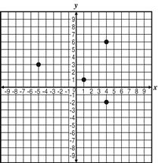
 | C.
 | D.
25. | 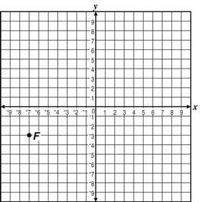  What are the coordinates of Point F on the graph below?
 | A. (–7, 3)
 | B. (–7, –3)
 | C. (–3, –7)
 | D. (–3, 7)

