6. NS.6c Coordinate Plane and Number Lines School Net Stinky Feet
26. | Which ordered pair is located in Quadrant I?
 | A. (–3, –2)
 | B. (3, –2)
 | C. (–3, 2)
 | D. (3, 2)
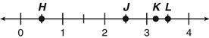
27. | Which point representson this number line?
 | A. H
 | B. J
 | C. K
 | D. L

28. | Which point is closest toon the number line?
 | A. T
 | B. U
 | C. V
 | D. W
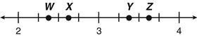
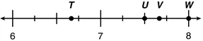
29. | Which point on the number line below is
 | A. W
 | B. X
 | C. Y
 | D. Z
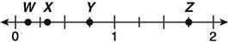
30. | Which letter best representson this number line?
 | A. W
 | B. X
 | C. Y
 | D. Z

31. | Which graph shows the ordered pairsand
 | A.
 | B.
 | C.
 | D.

32. | Which line passes through the point (3, 4)?
 | A.
 | B.
 | C.
 | D.

33. | Which of the following coordinates lies outside the circle shown below?
 | A.
 | B.
 | 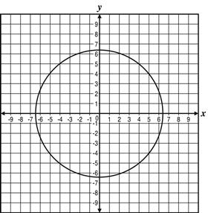
 | C.
 | D.

34. | Which ordered pair is located in Quadrant II?
 | A. (5, 7)
 | B. (5, –7)
 | C. (–5, 7)
 | D. (–5, –7)
35. | What is the value of Point C on this number line?
 | A. 0.208
 | B. 0.280
 | C. 0.302
 | D. 0.320
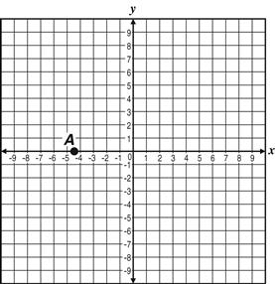
36. | What are the coordinates of Point A?
 | A.
 | B.
 | C.
 | D.

37. | Which number line shows the section that could contain the value 2.25?
 | A.
 | B.
 | C.
 | D.
38. | 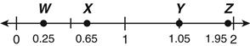  Which point is labeled with an incorrect value?
 | A. W
 | B. X
 | C. Y
 | D. Z
39. | Which point is (–7, 4)?
 | A. P
 | 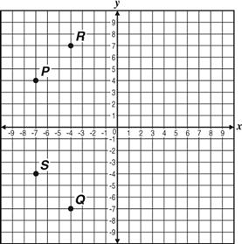
 | B. Q
 | C. R
 | D. S

40. | 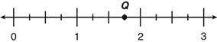  Which number is closest to Point Q on the number line below?
 | A.
 | B.
 | C.
 | D.
41. | Which number line represents the graph of 32?
 | A.
 | B.
 | C.
 | D.

42. | What are the coordinates of Point G on the graph?
 | A.
 | B.
 | C.
 | D.
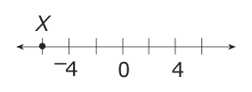
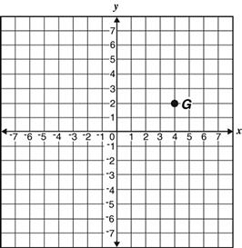
43. | Where is point X located on the number line below?
 | A. –2
 | B. –3
 | C. –5
 | D. –6
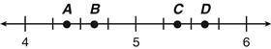  44. | Which point representson the number line below?
 | A. A
 | B. B
 | C. C
 | D. D

45. | Alissa made a timeline showing the dates different inventions were discovered. The sewing machine was invented in 1846.  At what point should the sewing machine be placed on this timeline?
 | A. Point W
 | 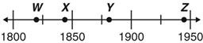
 | B. Point X
 | C. Point Y
 | D. Point Z
46. | 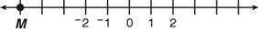  What number does Point M represent on the number line?
 | A.
 | B.
 | C.
 | D.
47. | Allen drew a triangle on a triangle coordinate plane, as shown below. Which ordered pair best represents the location of the vertex of the triangle that is nearest to
 | A.
 | B.
C.
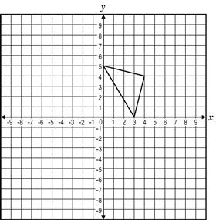
 | D.

48. | On the coordinate plane below, which point represents the coordinate?
 | A. P
 | B. Q
 | 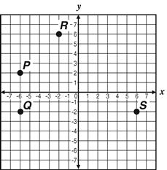
 | C. R
 | D. S
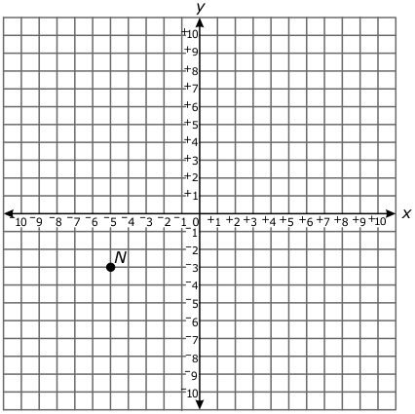
49. | What are the coordinates of point N?
 | A. (–5, –3)
 | B. (–5, 3)
 | C. (–3, –5)

50. | On this vertical marker, point W will be located 10 units above point S.  Where will point W be located on the marker?
 | A. –2
 | B. 8
 | C. 10
 | D. 12
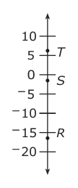
51. | What are the quadrant and coordinates that best describe the location of Point T?
 | A. second quadrant at
 | B. second quadrant at
 | 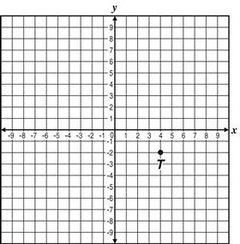
 | C. fourth quadrant at
 | D. fourth quadrant at
52. | 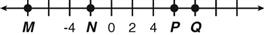  What point represents 8 on the number line?
 | A. M
 | B. N
 | C. P
 | D. Q
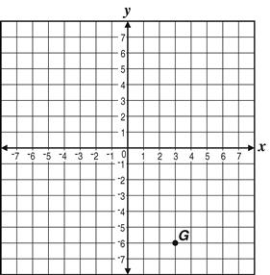
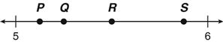
53. | Which letter best representson the number line?
 | A. P
 | B. Q
 | C. R
 | D. S
54. | What are the coordinates of Point G on the graph below?
 | A. (3, 6)
 | B. (–3, 6)
 | C. (3, –6)
 | D. (–3, –6)
55. | Which point representson this number line?
 | A. Q
 | B. R
 | C. S
 | D. T
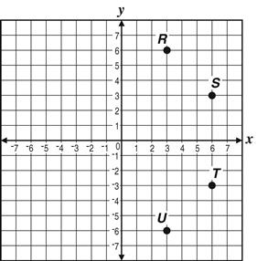
56. | Which of the points on the graph below is located at (6, –3)?
 | A. R
 | B. S
 | C. T
 | D. U

57. | Which point representson the number line below?
 | A. J
 | B. K
 | C. L
 | D. M

58. | Where is point J located on the number line below?  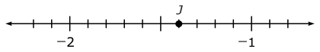
 | A.
 | B.
 | C.

