6.G.4 Mastery Connect
- The net of a cube with side lengths of 4 in. is shown below.
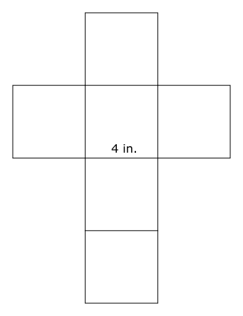
What is the surface area of the cube?
- 16 in.²
- 24 in.²
- 64 in.²
- 96 in.²

- The net of a square pyramid is shown below.
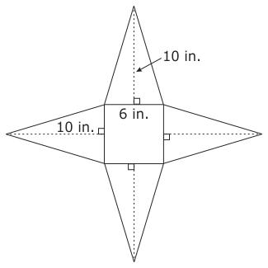
What is the surface area of the pyramid?
- 120 in.²
- 156 in.²
- 200 in.²
- 276 in.²

- A store uses the box below for gifts.
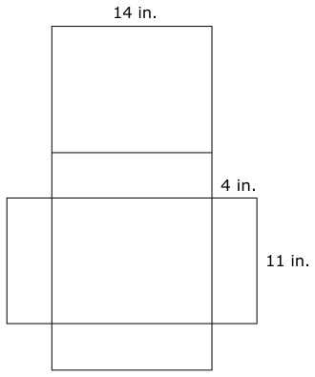
What is the minimum amount of wrapping paper needed to cover the box?
- 396 in.²
- 484 in.²
- 508 in.²
- 616 in.²

- What is the surface area of the rectangular prism below?
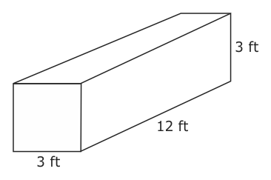
- 18 ft²
- 45 ft²
- 108 ft²
- 162 ft²

- Michael has a set of wooden cubes he is painting. One of the cubes is shown below.
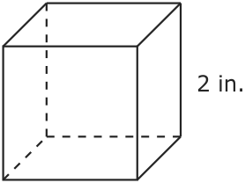
What is the surface area of this cube?
- 24 in.²
- 16 in.²
- 12 in.²
- 8 in.²

- What is the surface area of this right rectangular prism?
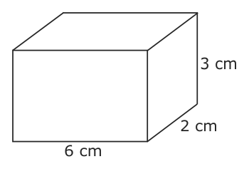
- 12 cm²
- 24 cm²
- 36 cm²
- 72 cm²

- Mia made a pencil box in the shape of a right rectangular prism.
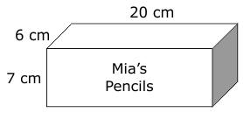
What is the surface area of the box?
- 390 cm²
- 604 cm²
- 840 cm²
- 1260 cm²

- What is the surface area of the triangular prism below?
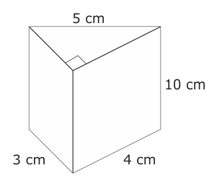
- 60 cm²
- 120 cm²
- 132 cm²
- 144 cm²

- Stan sketched the net below to determine the amount of material he needs to make his own tent.
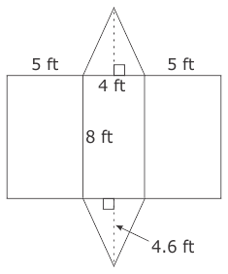
What is the minimum amount of material Stan needs to make the tent?
- 131 ft²
- 140 ft²
- 149 ft²
- 160 ft²

- The net of a square pyramid is shown below.
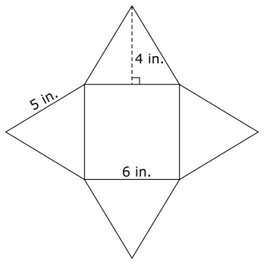
What is the surface area of the square pyramid?
- 60 in.²
- 84 in.²
- 120 in.²
- 132 in.²

