Area of Irregular Figures Name: ________________________
Schoolnet Homework Date: _______________ Core: _____

- Polygon PQRS is composed of a rectangle and a right triangle.
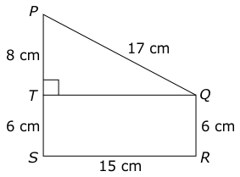
What is the area of polygon PQRS?
- 150 cm²
- 158 cm²
- 210 cm²
- 226 cm²

- The figure below is made of square and a triangle.
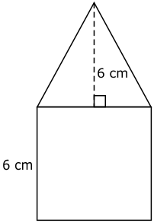
What is the area of the figure?
- 30 cm²
- 54 cm²
- 72cm²

- What is the area of the figure below?
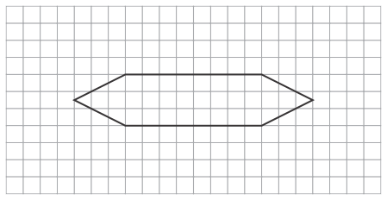
- 21 units²
- 33 units²
- 42 units²
- 52 units²

- A student created this rhombus in the diagram by the drawing two identical triangles.
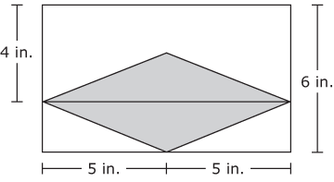
Which whole number represents the area, in square inches, of the rhombus?
- 10
- 16
- 20
- 22

- What is the area of the figure below if the measurements shown are in inches?
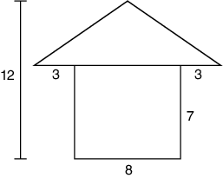
- 56 in²
- 71 in²
- 91 in²
- 126 in²

