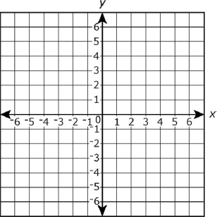
- On a coordinate graph, triangle PQR has vertices at P(1, -2), Q(4, -6), and R(1, -6). What is the area of the triangle PQR?

- Line segment AB has endpoints A(-4, 4) and B(2, 4). What is the length of line segment AB?

- The points on the coordinate plane represent 3 vertices of a rectangle. What is the perimeter of the rectangle?
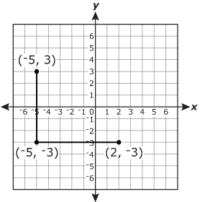

- A polygon has vertices at (-3, 1), (-2, -3), (5, -3), and (4, 1). What is the name of this polygon?

- Mr. Swenson plotted the coordinates (2, 4), (5, 4), and
(2, 1) on a coordinate plane. He wants to create a square with the points. What point would be the fourth vertex of the square?

- What polygon is formed by the coordinates (-2, 3), (2, 3), (2, 0), and (-2, 0)?

- Square PQRS has two of its vertices at coordinates Q(2, 3) and S(-3, -2). Which coordinates could be vertex R?

- A map of a triangular garden is plotted on a coordinate plane. The vertices of the triangle are located at (-5, 6), (6, 6), and (0, 0). Each unit on the coordinate plane represents 1 foot (ft) in the real garden. What is the area, in square feet, of the entire garden?
