11. | A biologist measures the temperature of a lake each week during the summer. This table shows seven weeks of measurements.  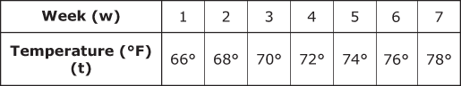  Which equation can be used to find the temperature, t, of the lake during these seven weeks, w?
 | A.
 | B.
 | C.
 | D.
12. | Edward is buying tickets to a football game.  Tickets Bought  Number (N) of Tickets Cost (C) of Tickets  1 $18  2 $36  3 $54  Which equation will help him determine the amount of money he will spend for tickets?
 | A.
 | B.
 | C.
 | D.

13. | A family went snow skiing. The chart below shows the cost to rent skis, y, based on the number of hours rented, x.  Ski Rental Cost  Hours Rented (x) Cost (y)  3 $48  5 $80  7 $112  9 $144  Which equation will calculate the family’s cost to rent skis for xhours?
 | A. y = 2x
 | B. y = 16x
 | C. y = 32x
 | D. y = 48x
. | 15. Alexis saves her money each week. Her savings are shown in the table below.  Week (x) Amount Saved (y)  1 $3  2 $6  3 $9  4 $12  Which equation calculates the amount of money Alexis has saved after x weeks?
 | A.
 | B.
 | C.
 | D.

