EE.9 Practice B

16. | Mr. Caldon bought 2 dozen eggs at the supermarket. When he got home, he fried three eggs. Which equation represents the number of eggs (E) Mr. Caldon has left?
 | A.
 | B.
 | C.
 | D.
17. | Mark is buying a new cell phone at Cell Phone Express. The sales brochure includes the chart below.  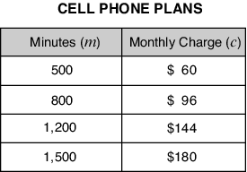  Which equation represents the relationship between the monthly charge (c) and the number of minutes (m) in the plans at Cell Phone Express?
 | A.
 | B.
 | C.
 | D.

18. | The table below shows the cost of CD cases based on the number purchased.  CD Cases Purchased (x) Cost (y)  3 $3.60  6 $7.20  9 $10.80  Which equation could be used to calculate the cost for xCD cases?
 | A. y = 1.20x
 | B. y = 3.60x
 | C. y = x + 1.20
19. | Which problem situation could be solved using the open sentence below?
 | A. Mrs. Garcia took 24 science papers home to grade. She graded k science papers before dinner. How many science papers did she have to grade after dinner?
 | B. Mrs. Garcia took 24 science papers and k reading papers home to grade. How many papers did she have to grade?
 | C. Mrs. Garcia had k science papers to grade. She now has 22 left to grade. How many papers did she grade already?
 | D. Mrs. Garcia has 22 science papers and 22 reading papers to grade. If she has k papers to grade in all, how many papers does she have to grade?

20. | The cost of a keyboard (k) is $40 less than the cost of a printer (p). Which of these equations could model this fact?
 | A.
 | B.
 | C.
 | D.

