EE.9 Practice C
21. | A student is selling bracelets to raise money for charity. The chart shows how much money he collects when he sells various numbers of bracelets.  Which equation best represents the relationship between the number of bracelets sold, b, and the amount of money raised, m?
 | A.
 | B.
 | 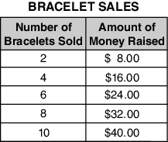
 | C.
 | D.
22. | Mario is buying cases of soda for a party. The table shows the number of sodas based on the number of cases.  Case (C) of Soda Number (N) of Sodas  1 24  2 48  3 72  Which equation should Mario use to determine the number of sodas to buy?
 | A.
 | B.
 | C.
 | D.
23. | Jim has a roll of 20 quarters. He uses 5 quarters to buy a snack from a vending machine. He uses 4 more quarters to buy a drink from another machine. Which equation can be used to figure out how many quarters (Q) Jim has left?
 | A.
 | B.
 | C.
 | D.
24. | Sophie used the equation y = x + 1 to represent that the length of a piece of fabric needed for a craft project (y) is always 1 inch greater than the length of the object made with the fabric (x). Which graph represents four solutions to Sophie’s equation?
 | A.
 | B.
 | C.
 | D.

25. | The table below lists coordinates on a line in a coordinate plane.  x y  2 4  5 10  8 16  11 22  Which equation describes the relationship between x and y?
 | A. y = x + 3
 | B. y = x + 2
 | C. y = 2x
 | D. y = 3x
26. | The line graph shows Callie’s height from ages 8 to 12.  Which list contains only independent quantities from the graph?
 | A. 8, 9, 11, 12
 | B. 8, 48, 9, 54
 | C. 48, 50, 52, 54
 | 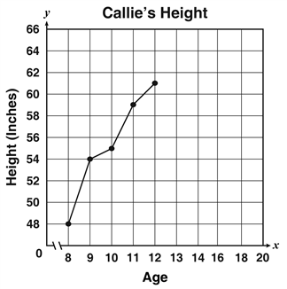
 | D. 48, 54, 55, 61

27. | Karen recorded her walking pace in the table below. What equation  Best represents this relationship?  Hours Walked (h) Miles Walked (m)  2.5 8.75  4 14

A. | h = m + 10

B. | h = 3.5m

C. | m = h + 10

D. | m = 3.5h

28. | The table below shows the cost of shrimp, S, based on their weight, w, in pounds.  Weight of Shrimp (w) Cost (S)  2 $13.98  4 $27.96  5 $34.95  7 $48.93  Which equation will calculate the cost of w pounds of shrimp?
 | A. S = w + 6.99
 | B. S = w + 13.98
 | C. S = 6.99w
 | D. S = 13.98w

29. | Which statement best describes the relationship between x and y in the graph?
 | A. y is twice x
 | 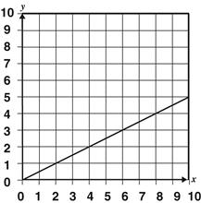
 | B. y is one half of x
 | C. y is two less than x
 | D. y is two more than x

30. | The Johnson family is driving across the country. The graph shows the distance they have traveled, y, based on their driving time, x.  Which equation would calculate the distance they have traveled after x hours of driving?
 | A. y = 60x
 | B. y = 50x
 | 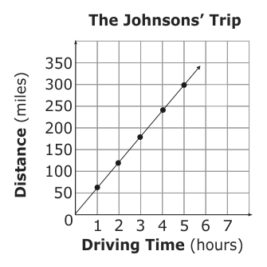
 | C. y = x + 60
 | D. y = x + 50

31. | Mary has been working on a project for school. She worked on it for 3 hours each day for 5 days. On the sixth day, she worked on it for 4 hours. Which equation can be used to figure out the total number of hours (H) Mary worked on her project in those 6 days?
 | A.
 | B.
 | C.
 | D.
32. | Mr. Bryer’s class went on a field trip to the science museum. Mr. Bryer was admitted for free, but it cost $100 to rent a bus for the trip and $4 for each student to get into the museum. The total cost of the trip was $244. Which equation can be used to find the number of students, s, that went on the field trip?
 | A.
 | B.
 | C.
 | D.
33. | Gallons of Gas Used (x) Miles Driven (y)  3 72  4 96  5 120  The table below shows the number, x, of gallons of gas used to drive y miles.  Which equation could be used to calculate the gallons of gas needed to drive y miles?
 | A. y = 24x
 | B. y = 48x
 | C. y = 72x
34. | Boxes of Paper  Number (N) of Boxes Reams (R) of Paper  1 8  2 16  3 24  Samuel is buying boxes of paper.  Which equation will help Samuel determine the number of reams of paper he will get if he buys 5 boxes?
 | A.
 | B.
 | C.
 | D.
35. | The table shows how many toys Claire owns and how many she will donate to charity. Which equation shows how many toys Claire will donate?  Claire’s Donation  Type of Toy Number of Toys (x) Number of Toys Donated (y)  Dolls 12 4  Blocks 9 3  Puzzles 6 2
 | A.
 | B.
 | C.
 | D.

36. | An express train travels between Boston and New York City. The table below shows the distance the train has traveled from Boston after various amounts of time.  BOSTON TO NEW YORK EXPRESS  TIME AND DISTANCE  Time (hours) Distance traveled (miles)  0 0  0.5 37.5  1 75  1.5 112.5  2 150  Let x represent the time in hours and y represent the distance the train travels in miles. Which equation best represents this relationship?
 | A.
 | B.
 | C.
 | D.
37. | Matt is reading a book at a constant rate of pages per hour. The table below shows the relationship between the number of hours, h, he reads and the number of pages, p, read in those hours.  hours 3 2 2 5  pages 75 50 50 125  Which equation represents this relationship?
 | A.
 | B.
 | C.
 | D.

38. | A pet store had 15 animals for sale. Today they sold 3 dogs and 1 cat. Which equation can be used to find how many animals (N) are left at the store?
 | A.
 | B.
 | C.
 | D.

39. | Cameron was shopping for a whole turkey. The table below shows the prices of turkeys, p, based on their weight in pounds, w.  Whole Turkey Prices  Pounds of Turkey (w) Price (p)  8 $10.32  12 $15.48  14 $18.06  Which equation would calculate the price of a turkey that weighed wpounds?
 | A. p = 1.29w
 | B. p = 4w
 | C. p = 5.16w
 | D. p = 8w

40. | The graph below shows the cost to play one round of miniature golf, y, based on the number of people in a group, x.  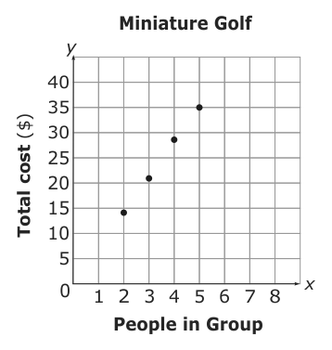  Which equation would calculate the cost to play miniature golf for x people in a group?
 | A. y = 5x
 | B. y = 7x
 | C. y = 10x
 | D. y = 14x

