G. 1 Area Schoolnet Mastery Connect

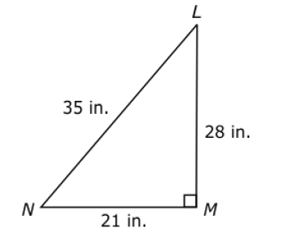
- Triangle LMN is shown. What is the area of triangle LMN?
A. 294 in.²
B. 490 in.²
C. 588 in.²
D. 980 in.²

- What is the area of a parallelogram with a length of 12.8 ft and a height of 7.4 ft?

A. 20.20 ft²
B. 40.40 ft²
C. 54.76 ft²
D. 94.72 ft²
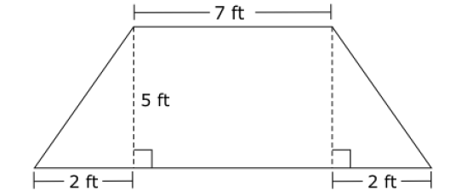
- A trapezoid is shown. What is the area of the trapezoid?

A. 34 ft²
B. 45 ft²
C. 55 ft²

- Sonia will paint a large triangular sign with a base of 14 ft and a height of 8 ft. What is the area of the sign?

A. 112 ft²
B. 56 ft²
C. 44 ft²
D. 22 ft²

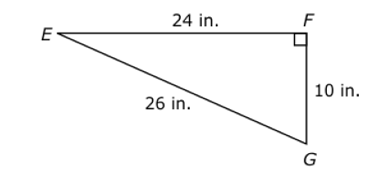
- Triangle EFG is shown. What is the area of triangle EFG?
A. 260 in.²
B. 240 in.²
C. 130 in.²
D. 120 in.²

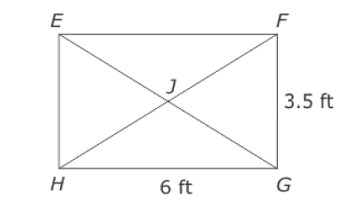
- Rectangle EFGH is shown. Point J is halfway between side EF. What is the area of triangle EJH?
A. 5.25 ft²
B. 10.5 ft²
C. 19 ft²
D. 21 ft²

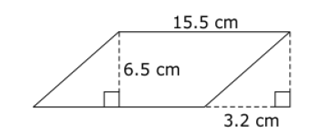
- What is the area of the parallelogram?

A. 79.95 cm²
B. 100.75 cm²
C. 111.15 cm²
D. 121.55 cm²

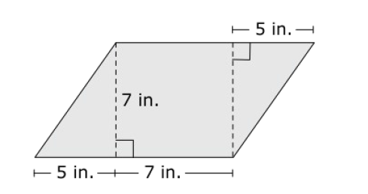
- Bonnie is cutting a parallelogram shaped piece of fabric for a blanket she is making. What is the area of this piece of fabric?
A. 59 in.²
B. 84 in.²
C. 119 in.²
D. 144 in.

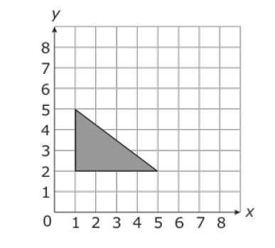
- What is the area of the triangle?

A. 12 units²
B. 8 units²
C. 6 units²

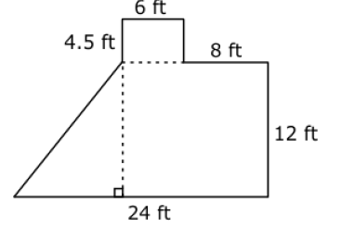
10. What is the area of the figure?

A. 375 ft²

B. 315 ft²

C. 255 ft²

D. 228 ft²

