Cornell Notes | Topic/Objective: Module 12 |  | Name:
 | Relationships in Two Variables |  | Class/Period:
 |  |  | Date:
Essential Question: How do you locate and name points in the coordinate plane? How can you identify independent and dependent quantities from tables and graphs? How can you use an equation to show a relationship between two variables? How can you use verbal descriptions, tables and graphs to represent algebraic relationships?
Questions: |  | Notes:  12.1  Coordinate Plane:  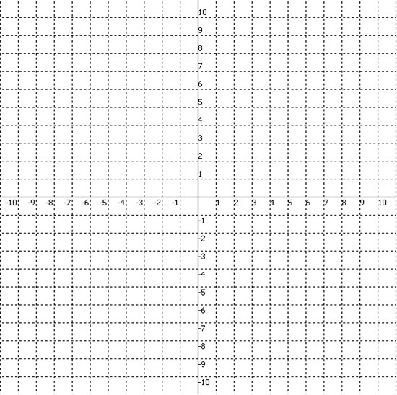  axes:  x-axis:  y-axis:  origin:  quadrants:  Ordered Pair:  Coordinates:  X-coordinate:  Y-coordinate:
Summary:
Questions: |  | Notes:  12.2  Dependent variable:  Independent variable:  Describing relationships between independent and dependent variables:  12.3  Writing an Equation Based on a table:  12.4  Graphing an Equation:
Summary:

