Surface Area Review
- The net of a cube with a 7-mm side length is shown below.
What is the surface area of the cube?

- The net of a square pyramid is shown below.
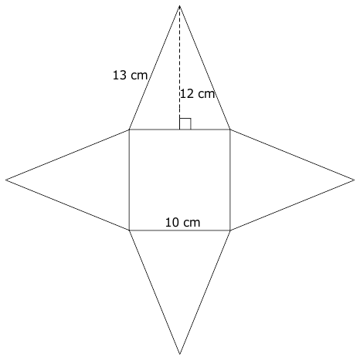
What is the surface area of the square pyramid?

- The net of a rectangular pyramid is shown below.
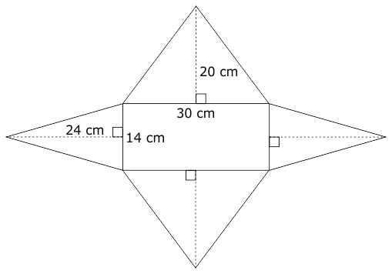
What is the surface area of the rectangular pyramid?

4. The net of a rectangular prism is shown below.
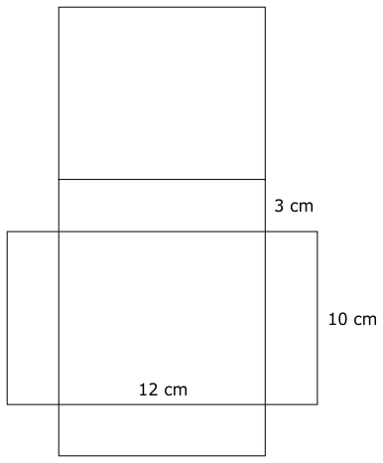
What is the surface area of the rectangular prism?

5. The net of a triangular prism is shown below. The height of each equilateral triangle is approximately 4.3 m.
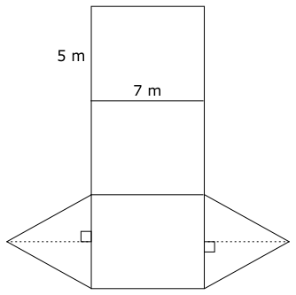
What is the approximate surface area of the triangular prism?

