G. 3 Polygons on a Coordinate Plane Mastery Connect

1. | A triangle has vertices at (2, –2), (2, 3), and (6,–2). What is the area of the triangle?
 | A. 9 units²
 | B. 10 units²
 | C. 18 units²
 | D. 20 units²
2. | Rectangle JKLM has vertices at the coordinates J(–3, 3), K(4, 3) and  L(4, –3). What are the coordinates of the vertex at point M?
 | A. (–3, 4)
 | B. (–4, 3)
 | C. (–3, –3)
 | D. (3, –3)
3. | Triangle PQR has vertices at coordinates P(2, 4), Q(1, –1), and R(3, –1). What is the area of triangle PQR?
 | A. 5 units²
 | B. 7 units²
 | C. 8 units²
 | D. 10 units²
4. | What polygon is formed by the coordinates (–2, 3), (2, 3), (2, 0), and  (–2, 0)?
 | A. rectangle
 | B. square
 | C. trapezoid
5. | Seth plotted the coordinates (1, 1), (1, 5), (5, 1), and (5, 5) on a coordinate plane. He connected each point in that order. He drew an additional line connecting (1, 1) and (5, 5). Which shapes did he draw?
 | A. a square and a rectangle
 | B. a rectangle and a triangle
 | C. two triangles
 | D. two rectangles
6. | What is the perimeter of a rectangle with vertices (–4, 3), (3, 3), (3, –2), and (–4, –2)?
 | A. 12 units
 | B. 17 units
 | C. 24 units
 | D. 35 units
7. | Rectangle WXYZ has vertices at W(3, 1), X(3, –4), Y(–5, –4), and  Z(–5, 1). What is the perimeter of rectangle WXYZ?
 | A. 22 units
 | B. 26 units
 | C. 40 units
8. | Triangle QRS has the coordinates Q(–1, 1), R(4, 1), and S(2, –5). What is the area of triangle QRS?
 | A. 15 units²
 | B. 18 units²
 | C. 25 units²
 | D. 30 units²
9. | Point N, located at (–6,0), is added to the triangle below to form rectangle KLMN.  What is the area of rectangle KLMN?
A. | 12 units²
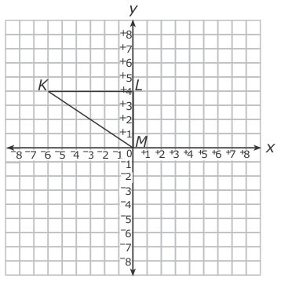
 | B. 16 units²
 | C. 20 units²
 | D. 24 units²
10. | The coordinates of three of the vertices of a rectangle are (–2, 4), (–2, –2), (3, 4). What are the coordinates of the fourth vertex of the rectangle?
 | A. (3, –2)
 | B. (2, –3)
 | C. (–2, 3)
 | D. (–3, 2)

