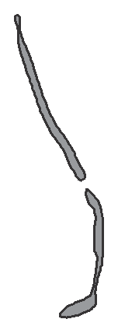

North Carolina READY End-of-Grade Assessment Mathematics

Grade 6

Student Booklet

Academic Services and Instructional Support
Division of Accountability Services

Copyright 2013 by the North Carolina Department of Public Instruction. All rights reserved.
Sample Questions

S1 Kerry walks 3 miles each day. How far will she walk in 7 days?

A 10 miles B 14 miles C 21 miles D 24 miles

S2 What number is represented by point P on the number line below?

P

–10 –9 –8 –7 –6 –5 –4 –3 –2 –1 0

S3 What fraction of the circle is shaded?

1 Joe will go to the swimming pool on 20 different days this month.

• A one-day pass to the pool is $2.25.

• A monthly pass to the pool is $30.00.

How much money will Joe save by buying a monthly pass?

A | $20
B | $18
C | $15
D | $12

2 A rectangular parking lot has an area of 2
3
of a square kilometer. The width is 1 of
2
a kilometer. What is the length, in kilometers, of the parking lot?

A 1
3

B 2
3

C 1 1
3

D 1 2
3

3 The price of a theater ticket increased from $7.50 to $7.75. The theater sold
315 tickets at the higher price. With the price increase, how much more did the theater earn on the tickets?

A | $78.00
B | $78.25
C | $78.50
D | $78.75

4 Hannah babysits to earn money.

• She charges $6.50 to babysit for the first hour.

• She charges $5.75 for each additional hour.

• Let n equal the number of hours after the first hour. Which expression represents how much Hannah charges?
A 12.25n

B 6.50 + 5.75n

C 6.50n + 5.75

D 6.50n + 5.75n

5 What is the value of (1 ) ?
7
3

A 3
7

B 1
7

C 3
343

D 1
343

6 Which choice shows a set of data that could be represented by the box plot shown below?

 | 0 5 | 10 | 15 | 20
A | 1, 3, 5, 6, 7, 7, 8, 13, 19, 20
B | 1, 3, 5, 6, 6, 8, 13, 14, 19, 20
C | 1, 2, 3, 5, 7, 8, 8, 13, 19, 20
D | 1, 5, 5, 6, 6, 6, 8, 13, 19, 20

Questions 7 through 15 require you to write your answers in the boxes provided on your answer sheet. Write only one number or symbol in each box and fill in the circle in each column that matches what you have printed. Fill in only one circle in each column.

7 A recipe requires 1
4
lb of onions to make 3 servings of soup. Mark has 1 1
2
lb of
onions. How many servings can Mark make?

8 A rectangular room has an area of 131 1
4
square feet. The length of the room is
12 1
2

feet. What is the width, in feet, of the room?

9 Allen is building birdhouses that require 1 -ft-long boards. How many pieces that
2
are exactly 1
2
ft long can be made from a board that is 8 1
4

ft long?

10 How much money should John get back when he uses $10.00 to pay for purchases totaling $5.25?

Express the answer as dollars.cents.

11 What is the product of 2.52 and 3.4?

12 At a store, Susan selected a pumpkin that weighed 35.2 ounces.

• Pumpkins cost $1.80 per pound.

• There are 16 ounces in 1 pound. How much did Susan’s pumpkin cost? Express the answer as dollars.cents.

3 2
13 What is the greatest whole number that is less than (5 )
÷ ( 3 ) ?
2 4

14 What is the value of
1 x 2
3
+ 2,
when x = 3?

15 Heather earns $8.00 per hour for walking a dog. How many hours must she work to earn $256.00?
This is the end of the calculator inactive test questions. Directions:
1. Look back over your answers for the calculator inactive questions. You will not be able to go back and work on these questions once you are given a calculator.

2. Raise your hand to let your teacher know you are ready to begin the calculator active test questions.

3. Do not begin work on the calculator active test questions until your teacher has given you a calculator.

16 One serving of Mike’s crackers has 150 calories and a mass of 30 grams. How many calories are in 6 grams of the crackers?

A | 5
B | 10
C | 25
D | 30

17 The ratio of nitrogen to potassium in a sample of soil is 12:9. The sample has
36 units of nitrogen. How much potassium does the sample have?
A 21 units B 27 units C 33 units D 48 units

18 To clean a tank, 3
4
cup of disinfectant is needed for every 2 gallons of water. How
many cups of disinfectant are needed for 20 gallons of water?

A 7 1
2

B 15

C 22 1
2

D 30

19 A laundry detergent is sold at four stores.

Store | Size (ounces) | Price
Hawkin’s Store | 60 | $6.50
Don’s Store | 54 | $5.50
Allen’s Market | 48 | $5.61
Value Market | 40 | $4.50

Which store has the lowest price per ounce? A Hawkin’s Store
B Don’s Store

C Allen’s Market

D Value Market

20 Marcy is taking two types of medicine.

• She takes one medicine every 6 hours.

• She takes the other medicine every 4 hours.

• She takes both medicines at 9:00 a.m.

At what time will Marcy take both medicines together again? A 1:00 p.m.
B 3:00 p.m. C 5:00 p.m. D 9:00 p.m.

21 Jeff recorded the average temperatures for six months. He will display the temperatures on a number line.

Month | Temperature (°F)
December | –5
January | –16
February | –15
March | 20
April | 24
May | 35

On the number line, which month’s temperature will be between February’s and
March’s temperatures?

A December

B January

C April

D May

22 A trapezoid in a coordinate plane has vertices (−2, 5), (−3,
What is the height of the trapezoid? A 3 units
B 5 units C 7 units D 9 units
−2), (2,
−2),
and (1, 5).

23 Which can be represented by the expression 17 – 2x?

A 17 less than twice a number x

B the difference between 17 and twice a number x

C a number x squared, subtracted from 17

D 17 less than a number x squared

24 Which expression is equivalent to 5y + 2y + 6x + 2y – x?

A 5x + 6y B 5x + 7y C 5x + 9y D 7x + 7y

25 Diana can use the equation y = 7x to calculate her pay, where y represents the amount of pay, and x represents the number of hours worked. How many hours did Diana work if she was paid $45.50?

A 5.5 hours

B 6 hours

C 6.5 hours

D 7 hours

26 | If y – | 18 = 14, what is the value of 3(y + 5)?
 | A | 27
 | B | 32
 | C | 96
 | D | 111

27 Karen recorded her walking pace in the table below. What equation best
represents this relationship?

Hours Walked (h) | Miles Walked (m)
2.5 | 8.75
4 | 14

A h = m + 10

B h = 3.5m

C m = h + 10

D m = 3.5h

28 The shaded area indicates the parking lot at a shopping center.
 |  |  |  |  | PA | R | KI | N | G | L | OT

y

x

hat is the total area of the parking lot? A 72 units2
B 86 units2

C 91 units2

D 120 units2

29 The right rectangular prism below is made up of 8 cubes. Each cube has an edge
length of 1
2

inch.

What is the volume of this prism? A 1 cubic inch
B 2 cubic inches

C 4 cubic inches

D 8 cubic inches

30 What is the area of the quadrilateral with vertices at (−1, 0), (2, 0), (2, 5), (−1, 5)?
and

A 15 square units B 12 square units C 10 square units D 5 square units

31 The net of a triangular right prism is shown below.

10 in.

3 in.

5 in.
8 in.

5 in.

What is the surface area of the prism? A 204 in.2
B 228 in.2

C 240 in.2

D 288 in.2

32 The data below represents the numbers of books that twelve students read.

2, 4, 7, 8, 9, 12, 14, 18, 19, 21, 30, 32

Which box plot correctly summarizes the data?

A Numbers of Books

0 10 20 30 40

B Numbers of Books

0 10 20 30 40

C Numbers of Books

0 10 20 30 40

D Numbers of Books

0 10 20 30 40

33 Which box plot represents a set of data with the largest interquartile range?

A

18 20 22 24 26 28 30 32

B

18 20 22 24 26 28 30 32

C

18 20 22 24 26 28 30 32

D

18 20 22 24 26 28 30 32

34 A company that makes boxes finds that 3 out of 20 boxes are damaged. What percent of the boxes are damaged?

A 12% B 15% C 25% D 34%

35 Jack drew a number line on his paper.

E F G H I J

Jack drew a new point 45% of the distance from point E to point J. Between which two letters does the new point lie?

A G and H

B I and J C F and G D H and I

36 Valerie is 64 inches tall. About how many centimeters tall is Valerie? (1 inch ≈ 2.5 centimeters)

A | 25.6
B | 30.6
C | 160
D | 180

37 Which point on the number line represents the number
− 4 1 ?
2

P Q R S

–6 –5 –4 –3 –2 –1 0 1 2 3 4 5 6

A P B Q C R D S

38 This table shows the number of miles four friends travel to get to school.

Student | Distance to School (miles)
Andie | 1 3  8
Helen | 1 2  3
Michelle | 1 5  9
Troy | 1 4  9

Who travels the greatest distance to school? A Andie
B Helen

C Michelle

D Troy

39 In the coordinate plane, what is the distance between (−3, 5) and (−3, − 8)?

A 3 units B 6 units C 8 units
D 13 units

40 Which choice is equivalent to the expression 4(x + 2y)?

A 4x + 8y B 4x + 2y C x + 8y
D 8xy

41 Which expression represents the perimeter of the triangle?

3k + 5
2k + 16

15 + 4k

A 9k + 36

B 10k + 25

C 20k + 25

D 24k + 36

42 The length of a rectangle is 6 units longer than the width, w. Which choice is a correct expression for the perimeter of the rectangle?

A 2w + 6

B 2w + 12

C 4w + 6

D 4w + 12

43 Jane wants to visit her sister.

• Her car travels x miles per gallon of gas.

• She will travel 1,000 miles to her sister’s house.

• Gas costs $3.50 per gallon.

Which expression shows how much Jane will spend for gas on the trip to her sister’s house?

A 1,000(3.50x)

B 3.50 (1,000 )
x

C 3.50 x
1,000

D 1,000 1
( )
3.50x

44 Suppose that a stove and a freezer together weigh at least 370 pounds. The weight of the stove is 170 pounds. Which inequality correctly describes these conditions for the weight of the freezer, f ?

A f ≥ 200

B f > 200

C f ≤ 200

D f < 200

45 The Wilsons want to put outdoor carpet on their porch.

12 ft

12 ft

Porch

6 ft
6 ft

6 ft

How much carpet will be needed for their porch? A 42 ft2
B 72 ft2

C 108 ft2

D 144 ft2

46 What is the volume of the right rectangular prism below?

2 inches

A 4 3
4

cubic inches

1 inches
1
1
4
2
1 inches

B 4 1
8
cubic inches

C 3 3
4
cubic inches

D 2 1
8
cubic inches

47 In the graph below, each grid square represents one square yard.

y

+6

+5

+4

+3

+2

+1

–6 –5
–4 –3
–2 –1 0
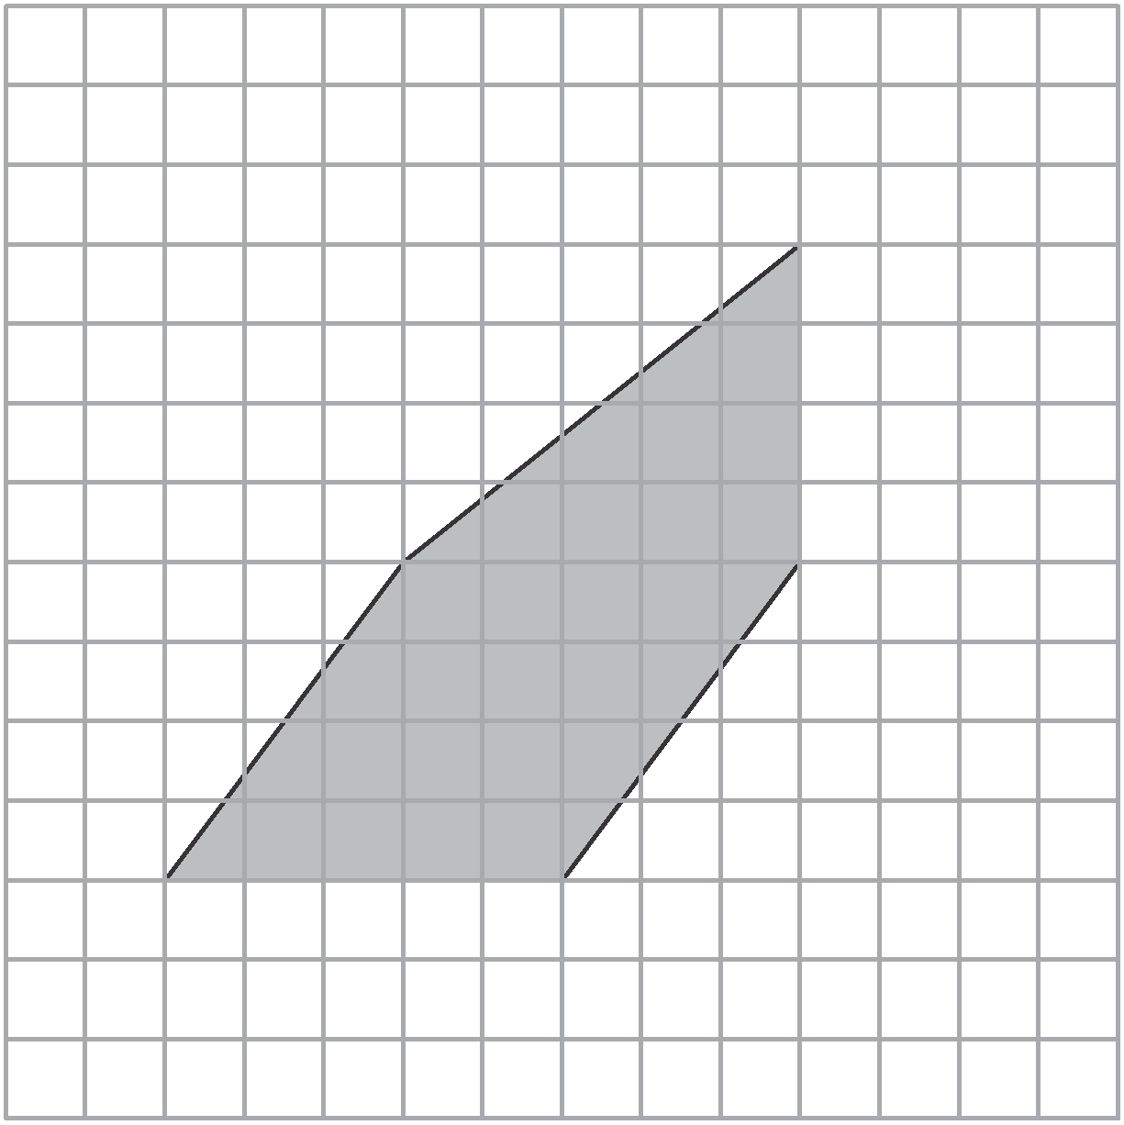–1
–2
–3
–4
–5
–6
+1 +2 +3 +4 +5 +6

What is the area of the shaded figure? A 20 yd2
B 30 yd2

C 36 yd2

D 40 yd2

48 Abby is making a decoration. When folded, the decoration is a triangular pyramid made of four congruent equilateral triangles. Approximately, what is the surface area of Abby’s decoration?

7 in. 6.06 in.

A 64 in.2

B 85 in.2

C 97 in.2

D 170 in.2

49 Katherine earned 84, 92, 84, 75, and 70 on her first 5 tests. What is the minimum grade Katherine needs to earn on the next test to have a mean of 84?

A 81

B 84

C 95

D 99

50 The weather station recorded the high temperature each day for 30 days. The graph of the temperature data is shown below.

High Temperatures

9

8
7
Number of Days
6
5
4
3
2
1
0
31– 40 41– 50 51– 60
61–70
71– 80
81– 90

Temperature (°F)

In which interval is the median temperature? A 41–50
B 51–60

C 61–70

D 71–80

