Surface Area Review
- The net of a cube with a 7-mm side length is shown below.
What is the surface area of the cube?

- Sheila has a box shaped like a right rectangular prism. She wants to cover the entire box with paper.
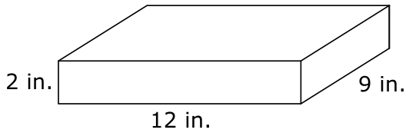
What is the area of space that will need to be covered?

- The net of a square pyramid is shown below.
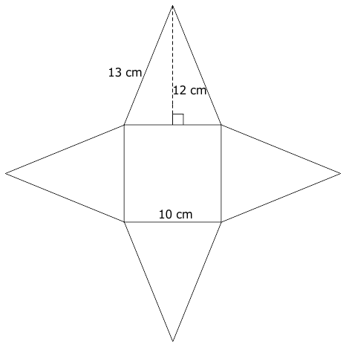
What is the surface area of the square pyramid?

- What is the surface area of the right rectangular prism below?
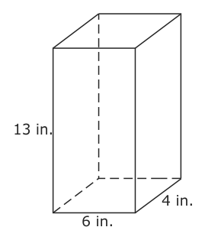

- What is the surface area of the cube below?
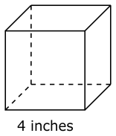

- The net of a rectangular pyramid is shown below.
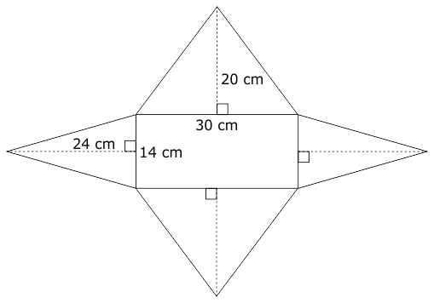
What is the surface area of the rectangular pyramid?

- A rectangular prism is shown below.
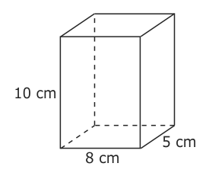
What is the surface area of the rectangular prism?

- A triangular prism is shown below.
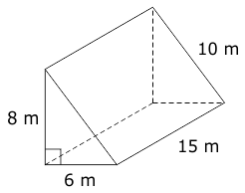
What is the surface area of the triangular prism?
- The net of a rectangular prism is shown below.
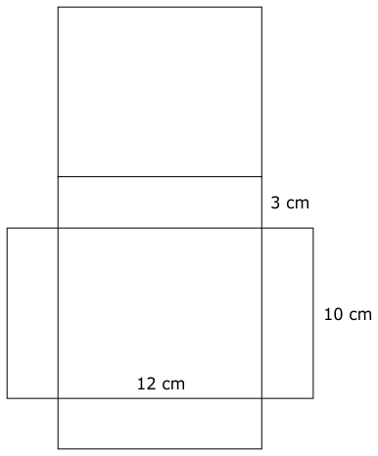
What is the surface area of the rectangular prism?

- The net of a triangular prism is shown below. The height of each equilateral triangle is approximately 4.3 m.
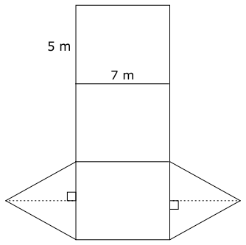
What is the approximate surface area of the triangular prism?

11. | 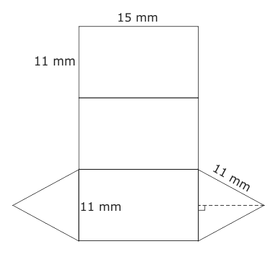  The net of a triangular prism is shown below. The heights of the triangles are approximately 9.5 mm.  What is the approximate surface area of the triangular prism?

A. | 500 mm²

B. | 600 mm²

C. | 705 mm²

D. | 785 mm²

12. | 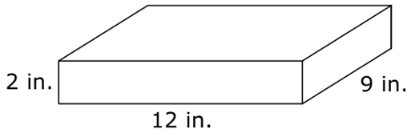  Sheila has a box shaped like a right rectangular prism. She wants to cover the entire box with paper. What is the area of space that will need to be covered?

A. | 300 in.²

B. | 216 in.²

C. | 150 in.²

D. | 126 in.²

13. | A triangular prism is shown below. What is the surface area of the triangular prism?

A. | 456 m²

B. | 408 m²

C. | 384 m²

D. | 360 m²

14. | The net of a cube with side lengths of 4 in. What is the surface area of the cube?

A. | 16 in.²

B. | 24 in.²

C. | 64 in.²

D. | 96 in.²

15. | A rectangular prism is shown below.  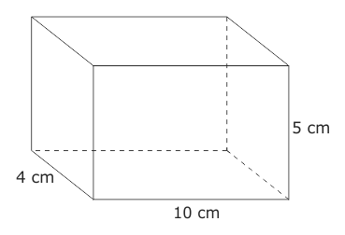  What is the surface area of the rectangular prism?

A. | 260 cm²

B. | 240 cm²

C. | 220 cm²

D. | 200 cm²

